Quant I – Fall 2013

Pr(Type I error) = Pr(reject H₀| H₀ is true) = α

If H₀ is true, then the parameter θ equals θ₀. Therefore, under the null, the sampling distribution of our estimator is Normal with mean θ₀ and standard deviation 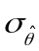.

In a one-tail test, our procedure is to specify an alternative hypothesis (for example, H_{A}: θ > θ₀), decide upon a confidence coefficient 1 – α, and from there specify a rejection region (the shaded area in the diagram below). We reject the null if we observe an estimate greater than 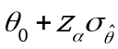.

If we do this, we will (purely by chance):

• observe an estimate in the rejection region 100 x α % of the time
(and thus falsely reject the null even though it’s true = commit Type I error)

and

• observe an estimate in the rejection region 100 x (1-α) % of the time
(and thus fail to reject the null given that it’s true = a desired result)

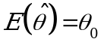
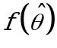
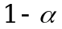
of area remains
Normal PDF

area under curve = 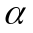

rejection region

Accept H₀ | H₀ true
(a desired result)
Reject H₀| H₀ true
(Type I error)

Thus the probability of committing type I error is α.

Pr(Type II error) = Pr(accept H₀| H_{A} is true) = β

Now consider the following thought experiment: suppose that instead of H₀ being true, it is the case that some exact alternative hypothesis, H_{A}: θ = θ_{A}, is true.

But as is always the case, we conduct our hypothesis test under the assumption that the null hypothesis, H₀ is true, i.e. H₀: θ = θ₀. As before, we proceed with the knowledge that under the null, the sampling distribution of our estimator is Normal with mean θ₀ and standard deviation . As before, we reject the null if we observe an estimate that is greater than .

But what is actually the case is that the sampling distribution of our estimator is Normal with mean θ_{A} and standard deviation .

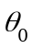
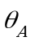
Accept H₀| H_{A} true
(Type II error)
Reject H₀| H_{A} true
(a desired result)
β = Pr(Accept H₀| H_{A} true)
α = Pr(Reject H₀| H₀ true)

rejection region

1 - β = Power
= 1- Pr(Reject H₀| H_{A} true)
= 1-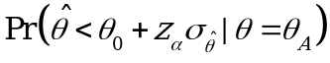
β
α

